Elevatelabs task-7

**Project Overview:**

Redesigning netmirror application

**Problem statement:**

If we click the menu icon one overlay will open here we can choose what ever we want. To close that overlay we need to click on the same icon.

**Research Insights:**

Difficult in the navigation section

**Wireframes:**



**Final UI Screens:**

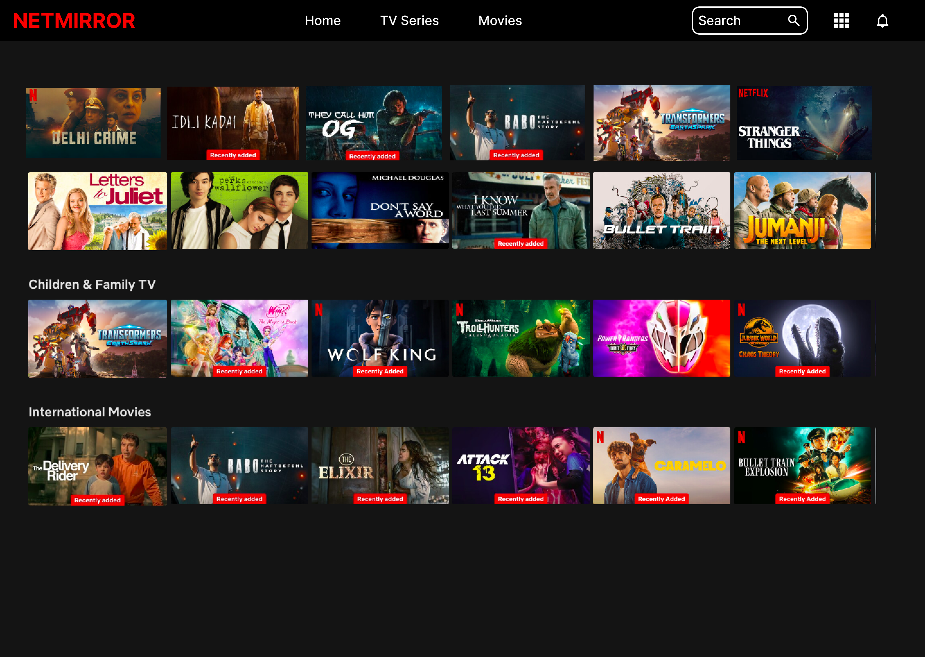

**Key Improvements:**

I aligned the **Home**, **TV Series**, and **Movies** menu items to the center and enhanced the menu overlay functionality. Now, the menu can be closed either by clicking the **menu icon** again or by clicking **anywhere outside** the menu area.

**Conclusion:**

This improvement provides a more **intuitive and seamless user experience**, ensuring easy navigation and smooth interaction with the menu on all screen sizes.